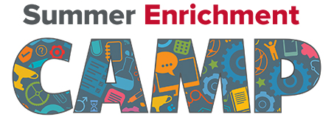
Hamilton County Elementary School
1st & 2nd Grade
June 14th — June 24th
(Monday-Thursday) 8:00am - 1:30pm
HCES Summer Enrichment Camp will provide fun, learning activities designed
to expand student experiences and enrich summer learning.
Breakfast and lunch will be provided. Bus transportation will also be provided.
Please complete the requested information below and return to the
school with your child before May 21, 2021. Limited spaces are available.
For more information, please contact the school at (386) 792-8000.
-----------------------------------------------------------------------------
Student’s Name: _______________________________ Grade Level (2020-2021): ______________
Parent(s)/Guardian(s) Name: ________________________________________________________
Home Address: ___________________________________________________________________
Parent’s E-mail: ___________________________________________________________________
Home Phone: _________________________ Parent/Guardian Cell: ________________________
Please indicate whether your child will be a parent pickup/drop-off or bus rider.
Bus Transportation Parent pickup/drop-off
Emergency Contact Information (other than parent/guardian listed above):
Contact #1 Name: _________________________________________________________________
Phone #: _______________________________ Relationship: ____________________________
Contact #2 Name: _________________________________________________________________
Phone #: _______________________________ Relationship: ____________________________

