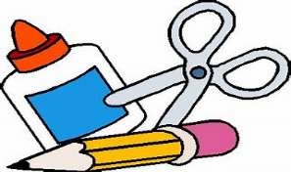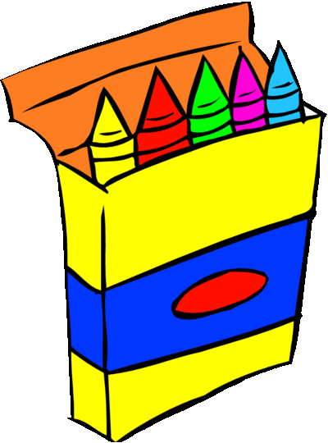
-NO rolling book bags – NO mechanical pencils – NO pencil sharpeners-
Hamilton County Elementary School
Supply List 2022-2023

Pre-K 3-Year Old Wish List  * Ziploc bags (all sizes)  * Kleenex  * Baby Wipes  * Clorox disinfectant wipes (any brand)  * Germ-X  * 2 packs of 24 count Crayola crayons  * 8 Elmer glue sticks  * Mat for naptime  * Beach towel or small blanket  * Change of clothes (clothes for weather, socks and underwear) with their name on each item | 2nd Grade  * 1 pair of headphones * 1 pencil pouch  * 3 boxes of Kleenex tissues * Bookbag  * 2 boxes of 24 count crayons  * 1 pack of coloring pencils  * 2 containers of Clorox wipes  * 2 packs of plain No. 2 pencils  * 2 composition notebooks  * 1 2-pocket vinyl folder-no prongs (preferably blue or  purple)  * 2 packs of cap erasers  * 2 packs of wide-ruled notebook paper
Pre-K Wish List  * Ziploc Bags (all sizes)  * Kleenex  * Baby Wipes  * Clorox disinfectant wipes (any brand)  * Germ-X  * 2- 24 pack Crayola crayons  * 8- Elmer glue sticks  * Washable markers  * Headphones  * Beach towel or small blanket  * Change of clothes (clothes for weather, socks and underwear) with their name on each item  *Regular sized book bag | 3rd Grade  * 2 packs of 12 count No.2 pencils  * 1 pair of scissors  * 3 glue sticks  * 1 box of 24 count crayons  * 4 composition notebooks  * 2 containers of disinfectant wipes  * Headphones  * Pencil box  * 1 pack of cap erasers  * Box of gallon Ziploc bags
Kindergarten  * 1 pack of pencils  * 4 packs of Crayola crayons  * 4 glue sticks  * 2 large, pink erasers  * 1 pair of safety scissors (no sharp points)  * 1 pair of headphones (no earbuds)  * 1 box of Kleenex tissue  * 1 container of Clorox or Lysol cleaning wipes  * 1 book bag  * Ziploc bags (any size) | 4th Grade  * 4 packs of pencils  * 3 composition notebooks  * 2 packs of index cards  * Glue sticks  * 1 pack of coloring pencils  * 1 pair of headphones  * 4 three-prong folders with pockets  * 1 pair of scissors  * 2 highlighters (yellow)  * 1 pack of 24 count crayons
1st Grade  * 2 packs of 24 count Crayola crayons  * 1 pair of child size scissors  * 4 glue sticks  * 2 packs of plain No. 2 pencils  * 2 containers of Clorox wipes  * 2 sets of ear buds or 1 pair of headphones  * 1 box of Ziploc bags  * 1 pack of pink rectangle erasers  * 1 box of Kleenex tissues  * 1 pack of wide-ruled notebook paper | 5th Grade  * 2 packs of Ticonderoga pencils  * 1 bottle of hand sanitizer  * 1 box of Kleenex  * 1 pack of yellow highlighters  * 2 containers of Clorox wipes  * 2 marble composition notebooks  * 4 packs of wide-ruled loose-leaf notebook paper  * 1 pack of glue sticks  * 1 pack of cap erasers  * 1 pencil pouch

