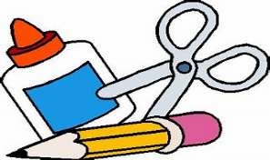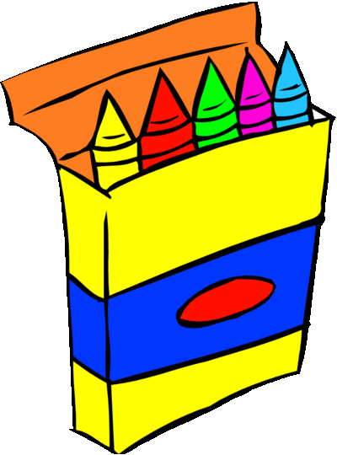
-NO rolling book bags – NO mechanical pencils – NO pencil sharpeners-
Hamilton County Elementary School
Supply List 2023-2024

Pre-K Wish List  * Ziploc Bags (all sizes)  * Kleenex  * Baby Wipes  * Clorox disinfectant wipes (any brand)  * Germ-X  * 2- 24 pack Crayola crayons  * 8- Elmer glue sticks  * Washable markers  * Headphones  * Beach towel or small blanket  * Change of clothes (clothes for weather, socks, and underwear) with their name on each item | 3rd Grade  * 2 packs of 12 count No.2 pencils * 2 boxes of Kleenex  * 1 pair of scissors  * 1 pack of 2-count glue sticks  * 1 box of 24-count crayons  * 3 composition notebooks  * 2 containers of Lysol wipes  * Headphones  * 1 pack of cap erasers  * Box of gallon Ziploc bags  * Box of quart Ziploc bags  * 2 packs of wide ruled notebook paper  * 2 packs of lined index cards
Kindergarten  * 1 pack of pencils  * 4 packs of Crayola crayons  * 4 glue sticks  * 2 large, pink erasers  * 1 pair of safety scissors (no sharp points)  * 1 pair of headphones (no earbuds)  * 1 box of Kleenex tissue  * 2 containers of Clorox or Lysol cleaning wipes  * Ziploc bags (any size) | 4th Grade  * 4 packs of pencils  * 3 composition notebooks  * 2 packs of index cards  * Glue sticks  * 1 pack of coloring pencils  * 1 pair of headphones  * 4 three-prong folders with pockets  * 1 pair of scissors  * 2 highlighters (yellow)  * 1 pack of 24 count crayons
1st Grade  * 2 packs of 24-count Crayola crayons  * 1 pair of child-size scissors  * 4 glue sticks  * 2 packs of plain No. 2 pencils  * 2 containers of Clorox wipes  * 2 sets of earbuds or 1 pair of headphones  * 1 box of Ziploc bags  * 1 pack of pink rectangle erasers  * 1 box of Kleenex tissues  * 1 pack of wide-ruled notebook paper | 5th Grade  * 2 packs of Ticonderoga pencils  * 1 bottle of hand sanitizer  * 1 box of Kleenex  * 1 pack of yellow highlighters  * 2 containers of Clorox wipes  * 1 marble composition notebook  * 4 packs of wide-ruled loose-leaf notebook paper  * 1 pack of glue sticks  * 1 pack of cap erasers  * 1 binder- 1”
2nd Grade
* 1 pair of headphones
* 3 boxes of Kleenex tissues
* 2 boxes of 24-count crayons
* 1 pack of coloring pencils
* 3 containers of Clorox wipes
* 2 packs of plain No. 2 pencils
* 1 composition notebook
* 2 Two-pocket vinyl folders (no prongs)
* 2 packs of cap erasers
* 1 pencil pouch
* 2 packs of 24-count crayons
* 2 packs of wide-ruled notebook paper

