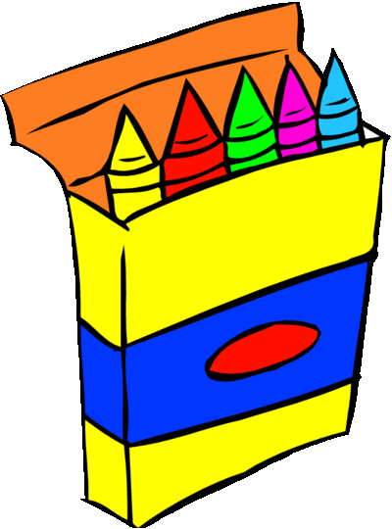
-NO rolling book bags – NO mechanical pencils – NO pencil sharpeners-
Hamilton County Elementary School
Supply List 2021-2022

Pre-K Wish List  * Large Elmer glue sticks  * 2 packs of 24 count Crayola crayons  * Baby wipes  * Kleenex tissues  * Clorox or Lysol wipes  * Hand sanitizer  * 1 pack of washable markers  * Ziploc bags (any size)  * Big Pencils  * Headphones  *Beach Towel | 3rd Grade  * 2 packs of 12 count No.2 pencils  * 1 pair of scissors  * 1 pack of glue sticks  * 2 packs of 24 count crayons  * 3 composition notebooks  * 2 containers of Lysol wipes  * 1 box of Kleenex tissue  * 1 pack of lined index cards  * 1 pair of headphones  * 1 pack of headphones  * 1 pencil pouch
Kindergarten  * 1 pock of pencils  * 4 packs of Crayola crayons  * 4 glue sticks  * 1 pair of safety scissors (no sharp points)  * 1 pair of headphones (no earbuds)  * 1 box of Kleenex tissue  * 1 container of Clorox or Lysol cleaning wipes  * 1 book bag | 4th Grade  * 4 packs of pencils * 1 pencil pouch  * 3 composition notebooks * 1 pair of scissors  * 2 packs of index cards * 1 pack of glue sticks  * 1 pack of coloring pencils * 2 highlighters (yellow)  * 1 pair of headphones  * 1 box of Kleenex tissue  * 2 containers of cleaning wipes  * 4 three-prong folders with pockets
1st Grade  * 2 packs of 24 count Crayola crayons  * 1 pair of child size scissors  * 4 glue sticks  * 2 packs of plain No. 2 pencils  * 2 containers of Clorox wipes  * 2 sets of ear buds or 1 pair of headphones  * 1 box of Ziploc bags  * 1 pack of pink rectangle erasers  * 1 box of Kleenex tissues | 5th Grade  * 2 packs of No.2 pencils * 1 pack of coloring pencils  * 1 container of hand sanitizer * Earbuds  * 1 boxes of Kleenex tissues * 1 pack of highlighters  * 1 pack of highlighters * 1 pack of glue sticks  * 2 containers of Clorox wipes * 1 pencil pouch  * 2 marble composition notebooks  * 2 packs of multi-colored index cards  * 1 pack of notebook dividers  * 3 three-prong folders with pockets (3 different colors)
2nd Grade  * 1 pair of headphones * 1 book bag  * 1 box of Kleenex tissues * 1 pencil box  * 2 boxes of 24 count crayons * Glue  * 1 pack of coloring pencils * 1 pair of scissors  * 1 pack of glue sticks  * 2 containers of Clorox wipes  * 3 packs of 24 count plain No. 2 pencils  * 3 composition notebooks  * 4 pocket folders (3 different colors) | 6th Grade  * 3 packs of No.2 pencils  * 2 packs of black pens  * 2 composition notebooks  * 1 pack of coloring pencils  * 4 pockets folders (4 different colors)  * 2 packs of index cards  * 1 pack of black expo markers  * 1 pencil pouch

